 Art Document

Document Issue: 1.0 Document Status: In Progress
Date Issued: Nov 04, 2001 Filing Path:
Document Title: Art Asset Mgmnt_Simpsons2
                - Author: Yayoi Maruno

Revision History
Issue | Date | Person | Reason - include problem #, ECN #, etc.
1.0 | Oct 03, 2001 | Yayoi, | Initial draft of document
1.1 | Dec 15, 2001 | Yayoi | Progression of information

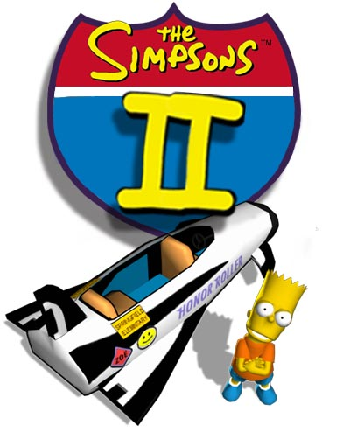

DOCUMENT SUMMARY

DESCRIPTION

This art asset management document is intended to provide detailed information on organization and maintenance of all art content for the game.

This document will be updated when necessary as we continue to refine our technology, game and art design.

OVERVIEW

A crucial part of game development is Art Asset Management from organization of art to simple naming convention structure. Without proper organization it can really impede on the efficiency of development process, making it difficult to re-iterate, fine tune, address technical issues such as memory optimization, troubleshooting breakdowns and can get extremely chaotic if people do not follow procedures. This global fundamental process and plan will assist in the organization of all art content.

AUDIENCE

This document is to be read by the majority of staff on the project, including the:

Art Director

Artists/Animators

Technical Director

Programmers
Art-Pipeline Programmers

Designers

GENERAL GUIDELINES

OVERVIEW

- All Artists on the team will be set up on D: Drive (Can set this up with the I-team support department (Cliff Haman). This is especially crucial for texture map path designation.

- Artists are given a task and a deadline by the Art Director and are required to review the art when completed. Furthermore the Project Manager will maintain weekly tasks and schedules.

- Artist will be given guidelines in terms of polygon count (vertices count) and texture resolution sizes. The Technical team will determine this guideline information. It is our responsibility to designate usage based on visual priority.

- Polygon count will be based on tri’s or triangles rather than quads.

- Artist will be using Maya 4.0 for the next development of games.

- Artist will have all P3d plug-ins set up in their Maya 4.0. Perforce will be set up with all P3d tools and exporters, rooted to update automatically in the proper folders.

- Artists must adhere to the naming convention structure for all art raw format and game content files. This is extremely crucial for the game build process.

- Perforce is used as a source control for all game development files. Artist are required to check in the Maya files (.mb/.ma), bitmap files (.bmp, .png, .tga) and game run-time format converted files (.p3d) P3d files place in Perforce will be the responsibility of the assigned artist to maintain this file.

- All artists are required to check their work on a PS2 viewer, Xbox viewer on NTSC to ensure that art content exports correctly, is within polygon guidelines and visibly looks correct.

- All artists will have a full working game build on their own hard drives. It is not required that they update their build everyday, but instead on a weekly basis as the build can be unstable on a daily basis. The main purpose for this is to check their artwork in the game and familiarize with the look and feel of the game.

- Directory structure will be set up so that all in-game art textures reside in a sourceimages directory. This will keep art organized. Within the source images directory, it will be broken down into the specific art caetgories such as characters, levels, SFX, etc.

- Always use lower case characters for naming convention unless otherwise specified.

ART CATEGORIES

All art content for game development will be broken down into specific categories. These are the following:

Characters (this includes main and AI characters that require skeleton)
- Modeling, skinning
- Texturing model
- Building Skeleton
- Binding
- Secondary modeling for animation
- Other geometry associated with the main character (e.g. Vehicles)
- Shaders

Character Animation
- Character animation
- Secondary animation
- Facial animation

Environments
- Level Design
- Terrain modeling
- Object/prop modeling and texturing
- Dynamic object modeling and texturing
- Background, terrain texture
- Atmospherics Effects
- Shaders

Lighting
- Lighting technique
- Pre-lighting, CBV lighting
- Shadow/light maps
- Dynamic lighting
- Volumetric Lighting

Front End
- Includes all selection menus, title screen, options, etc.
- Front End graphic and layout design and implementation
- 3d modeling, texturing and animation
- SFX animation/texture animation/procedural animation
- Font design (system true type font)

Heads Up Display
- HUD layout design and implementation
- 3d Animation
- Sprite animation
- Procedural animation
- Back end design (includes pause menu, end menu, high score etc..)

Special Effects
- Particle system
- Texture animation
- Vertex animation
- Shader and effects

NIS Non-interactive (in-game) sequences
- Character Animation
- Camera path implementation
- SFX implementation
- Lighting

FMV (Pre-rendered Video)
- High resolution modeling
- Lighting
- Animation and facial animation
- Camera animation
- Sfx
- Editing compositing
- Dialogue

OVERVIEW

Directory structure is the basic foundation of managing and maintaining files. Each art category will have a structure set up in our source-managing software tool, PERFORCE.

Each game team will also be provided with a server to place all raw format art such as references images, Texture CD images, etc. Currently the T: drive is our Server but will soon have access to a new server provided by the I-team support department (Cliff Haman)

All art categories will begin at the root directory of ART.

PERFORCE

Perforce is a source management software program that manages and maintains all our art content files, both raw and game format, game code and tools.

Perforce will keep a history of all files as they are checked in. It will ask for a description of the updates done to file. Artist are required to be as descriptive in their updates as this will assist in any potential troubleshooting.

Perforce will sync all files from the folder onto your hard drive. It will be set up that your files will be synced to a D: drive will proper paths to keep consistent if everyone else on the team. Again this is crucial for texture map paths set up in Maya.

A file can only be checked out by one person at a time. This will prevent any issues regarding overwritten files by accident.

Below is an example of how to check out and submit files using PERFORCE.

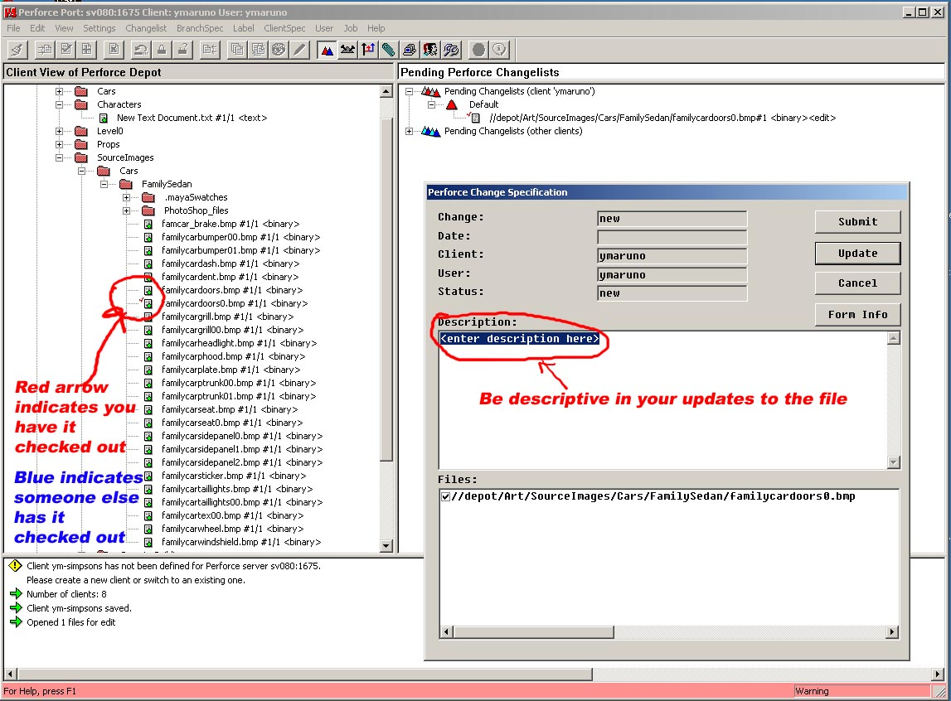

Art Directory Structure
This is the general management of all art assets in the game that will be maintained in perforce. All art assets will be generally broken down in relation to the art categories.
The root directory of ART for all art content which includes maya file, any texture or bitmap file, psd file, and p3d file.

ROOT DIRECTORY STRUCTURE
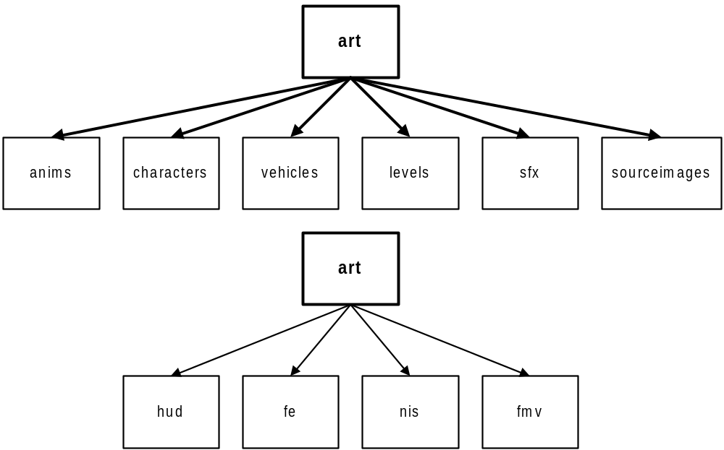

CHARACTER ANIMATION DIRECTORY STRUCTURE
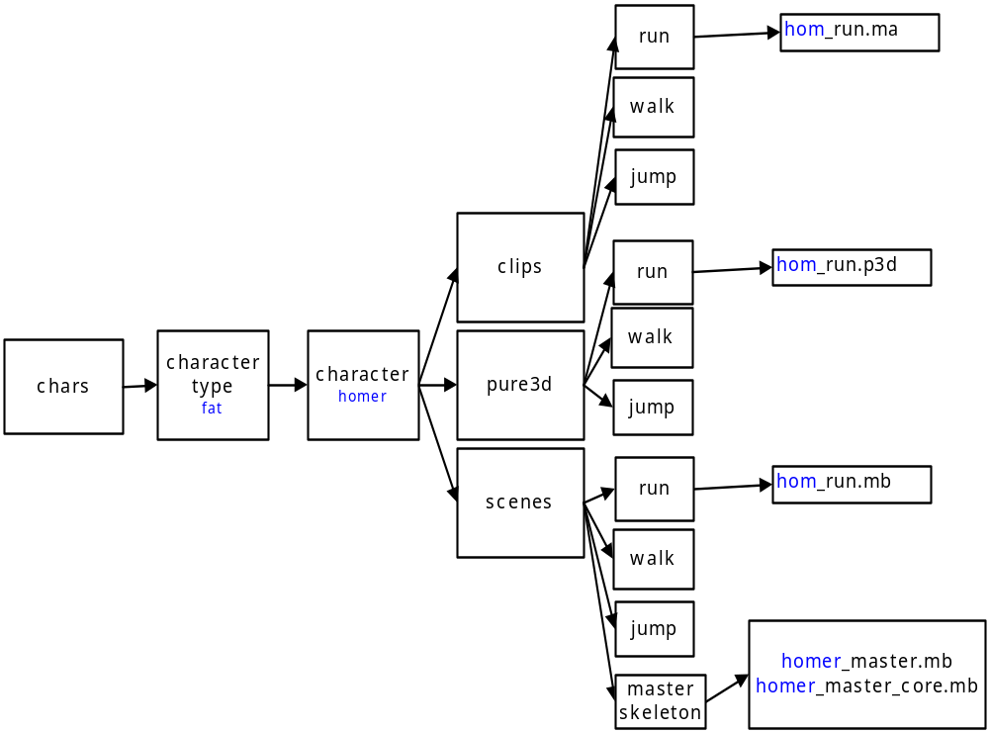

CHARACTER DIRECTORY STRUCTURE

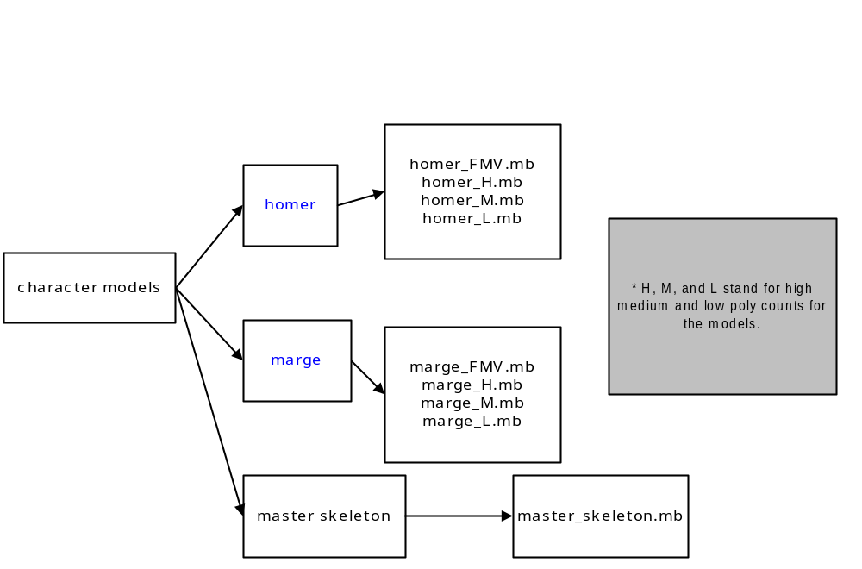

LEVEL DIRECTORY STRUCTURE

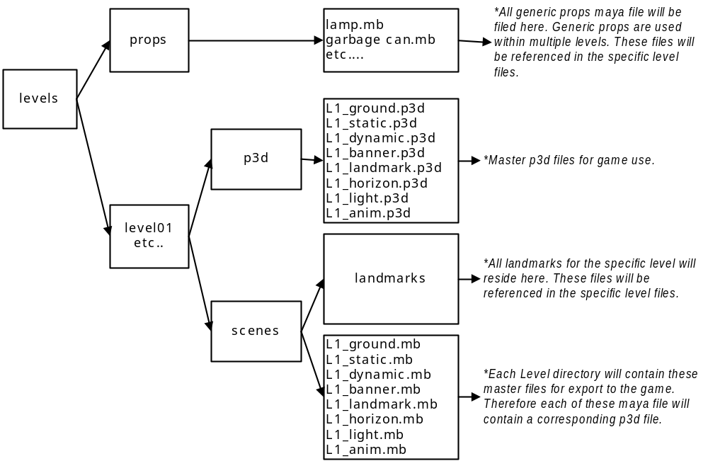

VEHICLES DIRECTORY STRUCTURE

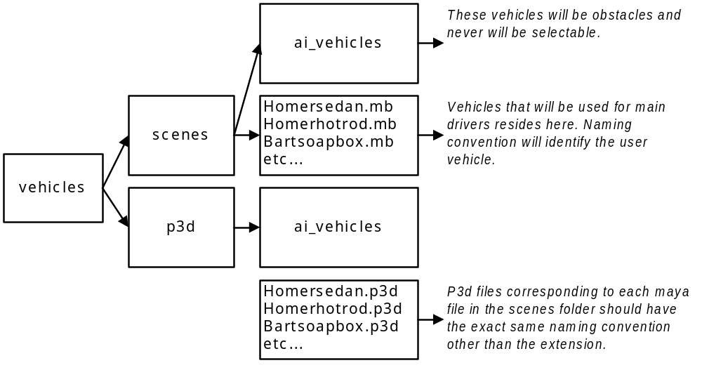

SFX DIRECTORY STRUCTURE
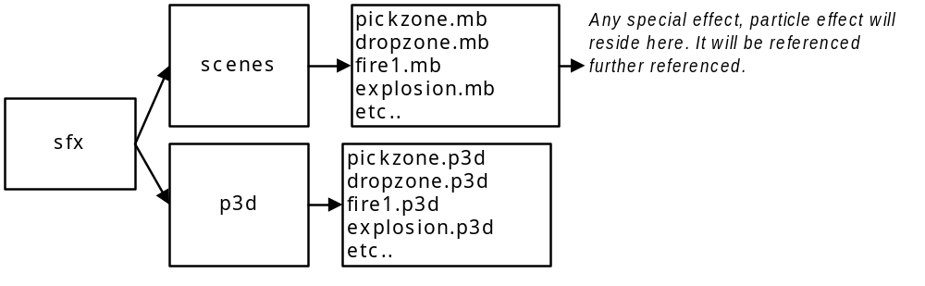

SOURCEIMAGES DIRECTORY STRUCTURE
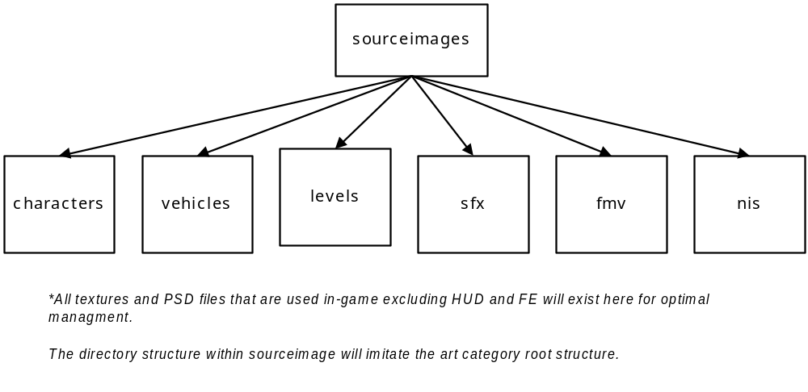

HUD DIRECTORY STRUCTURE
*To be added

FRONT END DIRECTORY STRUCTURE
*To be added

NIS DIRECTORY STRUCTURE
*To be added

FMV DIRECTORY STRUCTURE

*To be added

